PURCHASE ORDERS

Once you have made a purchasing decision and a Purchase Order is required, the initial step of the PO process is creating a requisition. Do NOT wait until you have invoice in hand to begin the PO process, as this will delay payment processing especially since there are specific documents that are required such as E-Verify in order to complete a PO in PeopleSoft.
For Demonstrations and Quick Guides for Requisition Processes, go to https://dnrintranet.org/fs/teamgeorgiamarketplace

- For Service Orders greater than $2,499.99, an E-Verify Form is required. See E-Verify Reporting
- For any Purchase of goods and/or services greater than $3,499.99, a SAM Federal Report is required. See SAM- Suspend Debar Review Reporting.
- One or both of these forms may be required and should be uploaded to Header Comments Section of the PO.

Once you stage your requisition, there are some basic fields to check for on every purchase order BEFORE you update the status to Pend Approval, which forwards it to Atlanta for both Purchasing and Accounting’s review and approval.

IF your PO is not approved within 1-2 days, you need to check for comments from Purchasing = Approve Amounts and Accounting= Approve Chartfields links in the Purchase Orders Section of PeopleSoft Financials. Review the comments and make the necessary adjustments. Once you re-save your Purchase Order, it will be available for the appropriate unit to review again and approve.

See the blue arrows for basic fields to check for on every PO:
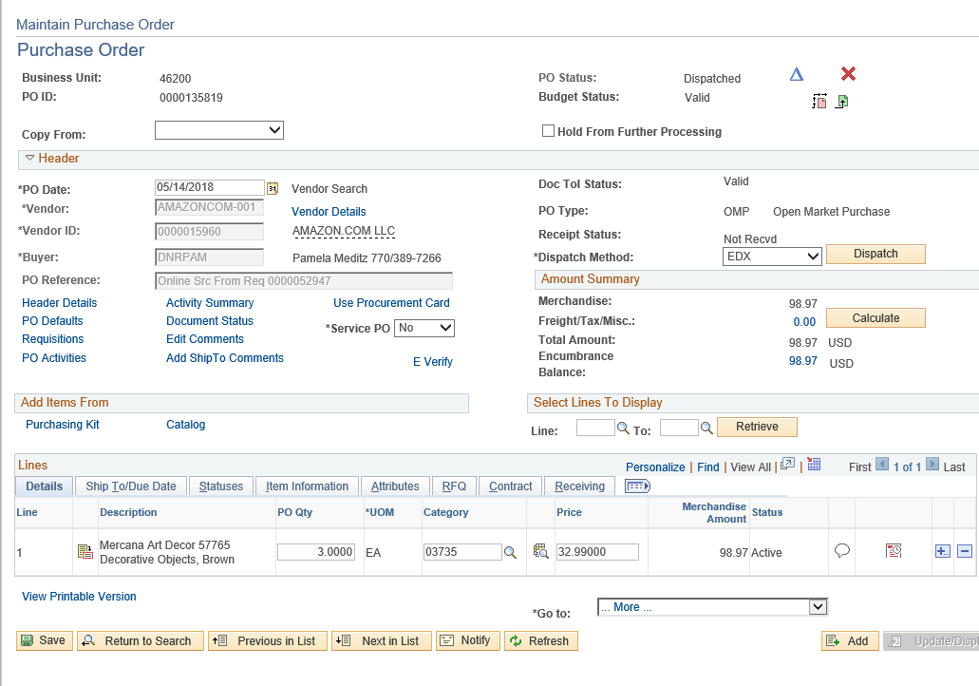

Vendor Details
This should be the remit address for this vendor. Click on the magnifying address to search/select other addresses and click on the Show Address Details button to view the full address.

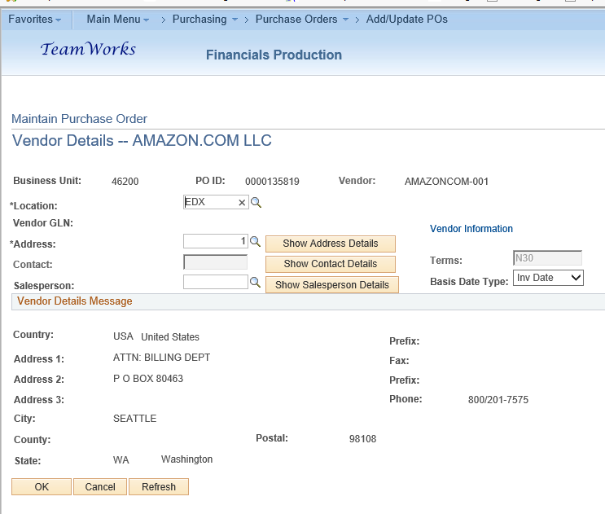

Header Details
PO Type can be: Open Market which includes Amazon Marketplace and other non-SWC suppliers; IGA Intergov’t Agency =GCI, Agency Contract would include Parks Agency Contracts listed on Staff Resources or other DNR Agency Contracts, SWC for Convenience or Mandatory can be found by viewing TeamGA…Staples is a convenience contract whereas Tractors is Mandatory, etc. Billing Location defaults to Commissioner’s office PO_111001 so change to your address.

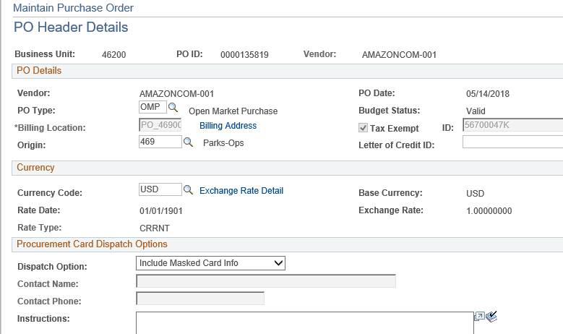

NIGP Code- You can use the magnifying glass in the requisition or PO to search by key words but know that this can give you multiple hits and it may not show you the category master title name such as 005 Abrasives. Without the master category title, you may have chosen a code that does not match
your product and you may be requested to change it. Also Amazon many times has the master code, 58000 which is not a valid code and you will get a red error message from PSoft. Here is the link to the complete NIGP list: http://ssl.doas.state.ga.us/PRSapp/PR_nigp_list.jsp?whereFrom=public

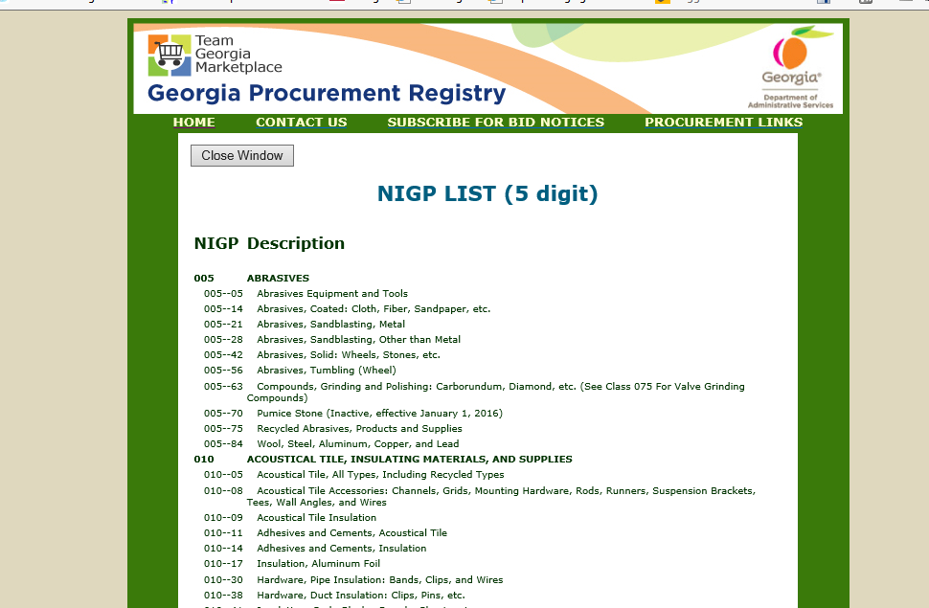

Category (NIGP) and Service PO
Remember: A service NIGP beginning with a “9” and $2,500 or greater requires an E-Verify. Refer to E-verify Reporting instructions

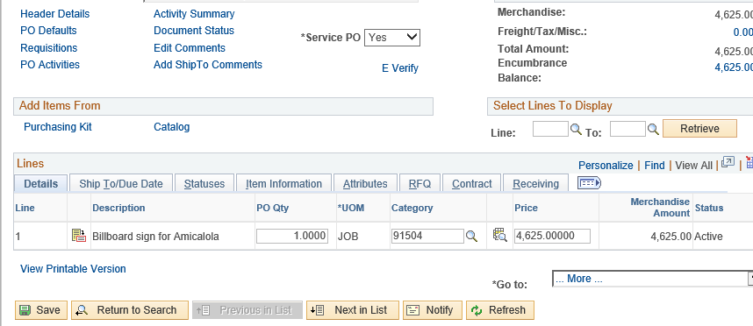
NIGP code

Header Comments
Have you uploaded E-Verify and/or SAM Federal Report? See E-Verify Reporting and SAM {Suspend Debar} Review instructions
For Annual Service Contract PO’s such as Pest, Termite, Trash, Alarm, etc. have you uploaded all of the contract and renewal(s) paperwork?
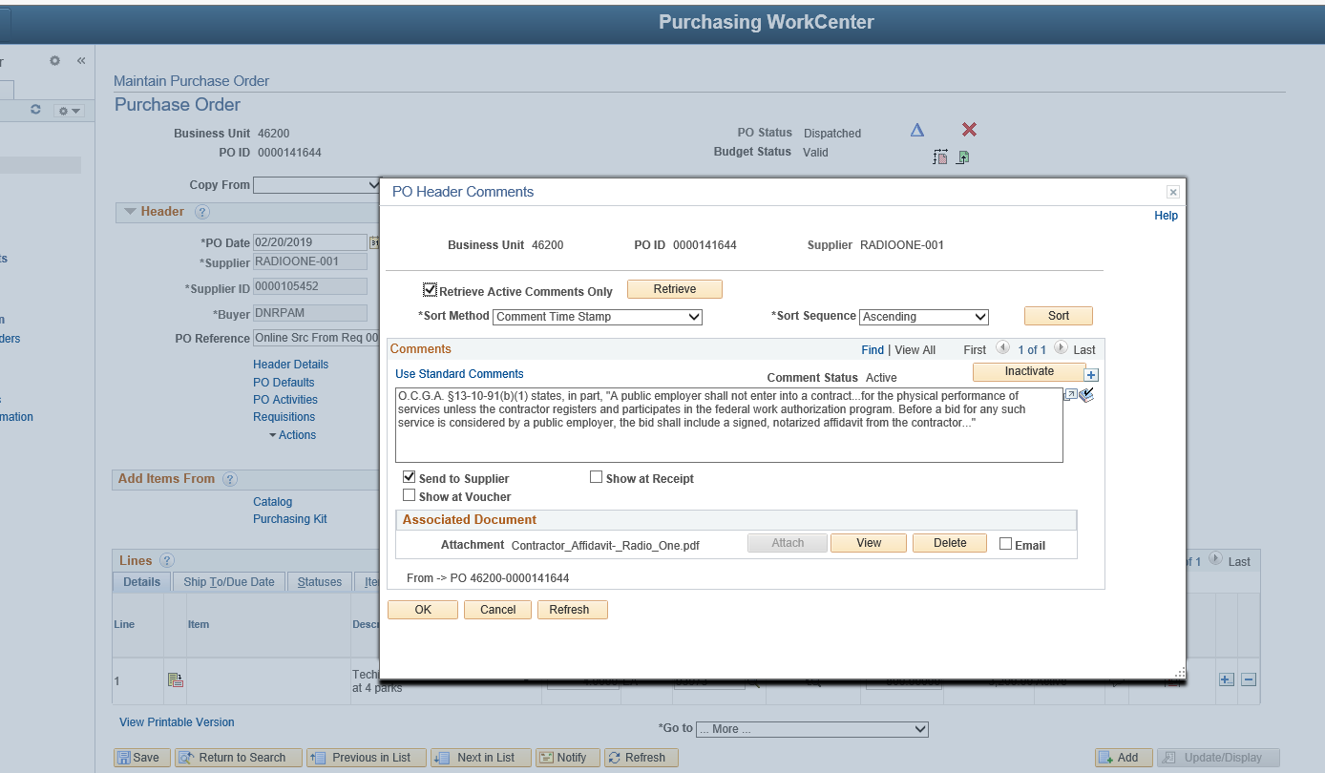

Contracts- Linking contract to PO line:
Whether an Agency or Statewide Contract, each line on the PO must be identified by the contract number. This can be done either in the requisition or purchase order. If blank, click on the magnifying glass icon and search for contracts for this vendor.

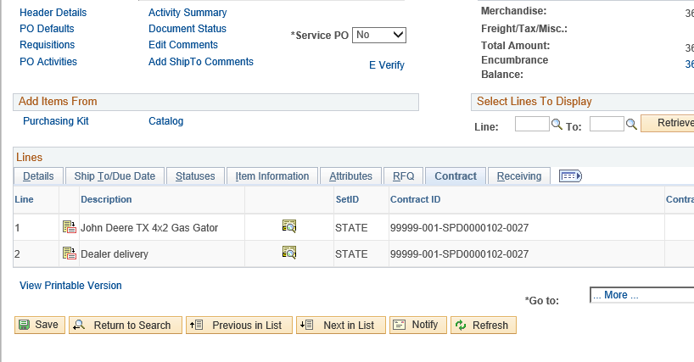

To link {select} a contract, click on the magnifying glass icon and a popup window will appear with contracts associated with the vendor.
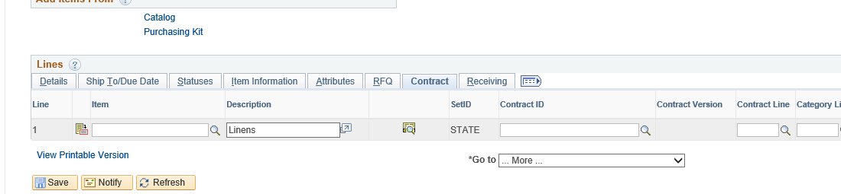

Click on the appropriate Blue contract link to add it to each Purchase Order line.
